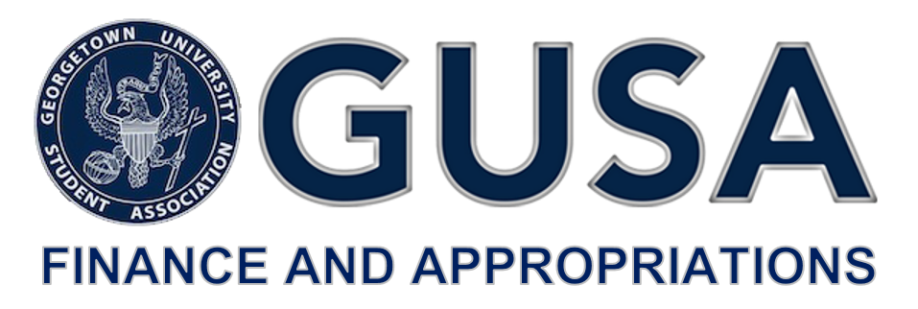

Dear Georgetown University Community,

The Finance and Appropriations Committee, commonly known as FinApp, is an essential branch of the Georgetown Student Government Association (GUSA). FinApp manages the allocation of the Student Activity Fee (SAF) to advisory boards and student groups on campus. The Student Activity Fee is a semester-based fee of $84.50 that every undergraduate student pays, which totals to over a million dollars. Since its implementation as an individual body in 2010, FinApp has facilitated the funding to a wide variety of clubs on campus through an application process, known as the Budget Summit.

The Finance and Appropriations Committee is a fifteen-member committee composed of GUSA Senators. Finapp is run by nine liaisons, three adjuncts, one vice-chair and one chair tasked with allocating the SAF budget among advisory boards. In addition, the Tenth Finance and Appropriations Committee is pleased to introduce the enactment of The Student Empowerment Fund (SEF). The SEF is a long-term student-funded financial asset designed to empower the student body in advocating for our interests. The fund is expected to be in effect at the start of the Spring semester of FY21. To prepare for such happening, this year’s FinApp is taking $50,000 from the current SAF budget with the intention of growing this fund over the next twenty years. More information will be available on this matter after the Budget Summit, and Office Hours will be open to the public on Wednesday, March 17 from 7:30 PM to 9:30 PM at the GUSA Office.

Today, FinApp is also happy to announce the beginning of the budget allocation process and release of application Part A and Part B for FY21. The appropriate applications may be accessed using the links below. Completed applications must be submitted by email to [gusafinapp@georgetown.edu](mailto:gusafinapp@georgetown.edu) by **Friday, February 21 by 6:30 PM.** You may access the timeline for the budget allocation process [here.](https://docs.google.com/document/d/14UsQysKyk6WT7bV4oYGvIJQqba6gN8ZmN4y15sl4CnM/edit?usp=sharing)

The Advisory Boards (ABCS, CAB, CMSF, CSJ-ABSO, Media Board, PAAC, SAC), GPB, Lecture Fund and the GUSA Executive-Elect are invited to apply for funding for FY21 using the [Part A Application](https://drive.google.com/file/d/1CfGfDQB8Cmw6-sJRWLbiLfDUF1QlxLfO/view?usp=sharing). These entities are guaranteed time for a presentation at Budget Summit, provided an application is submitted. Liaisons are expected to meet with the leadership of their coverage entities to walk through this timeline, explain the application, and ensure that the full Committee is appropriately prepared to provide assistance to applicants.

Groups that do not fall within the aforementioned collective and are not supported by one of the Advisory Boards are eligible to submit the [Part B Application](https://drive.google.com/file/d/1dGrhIXZijTJrFMykYPdx5RU3EZUoo9wJ/view?usp=sharing) for funding that will be reviewed by FinApp. If the application is accepted, the admitted entity will be assigned an Adjunct Committee Member to assist with any preparation leading up to Budget Summit.

FinApp looks forward to working with each applicant throughout this process. Please direct any and all questions to [gusafinapp@georgetown.edu](mailto:gusafinapp@georgetown.edu), with Director of the Center for Student Engagement Aysha Dos ([ad1578@georgetown.edu](mailto:ad1578@georgetown.edu)) cc’d.

Honestly,

Juliana Arias

*Chair, GUSA Finance and Appropriations Committee*